Teledu
Pam wyt ti’n hoffi neu ddim yn hoffi?

Resource | Teaching and Learning | Notes
Power Point  Pam  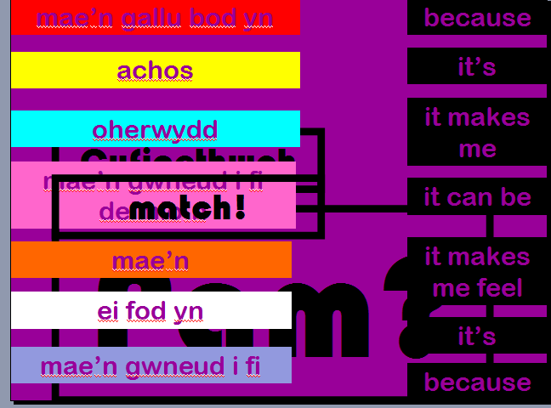  Slide 1 | - Click to reveal the question “Pam” and explain that by then end of the lesson, pupils will be able to answer why they like or dislike television programmes to a higher standard.  - Click to reveal words and phrases in English and ask pupils to translate.  - Click to reveal the Welsh and ask pupils to match the correct answers.  - Clicking on the Welsh boxes will change the correct English answer to the corresponding colour.  - Ask pupils to use the words to form sentences.
Slide 2  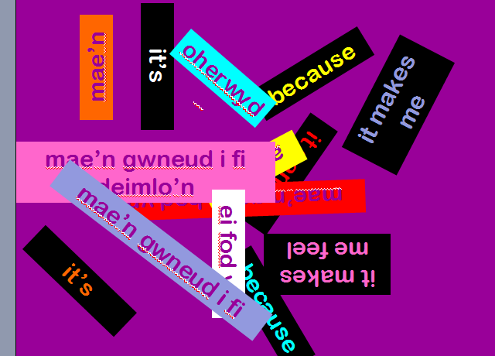 | - A click will cause the words and phrases on the previous slide to appear one after the other.  - Pupils shout the translation.
Slide 3 – 4 | - Encourage pupils to use their thinking skills in trying to restructure a paragraph that includes vocabulary and phrases learnt. The paragraph then acts as a model answer to which the pupils can refer to aid their writing. Pupils may work in pairs or groups.  - Click 1: Reveals instructions.  - Click 2: Reveals the paragraph in parts.  - Click 3: Reveals the ‘Dechrau’ (Start) prompt. 2 seconds after, the paragraph will be revealed in English for 3 seconds as a clue for pupils. At 7-second intervals, the same paragraph will appear a further 7 times. Some pupils will make use of it, others not. A bomb sound will indicate the end of the task.  - Click 3: Reveals instructions.  - Click 4: Reveals verification box.  - Teacher or pupil to then click on any of the paragraph parts for it to disappear from the left of the screen only to appear in its correct place in the verification box. Click each one until all have appeared in the box. Ensure that pupils understand the order.  - Clicking the ‘thumbs up’ icon will reveal the text as a paragraph.  - Pupils should be encouraged to read aloud and to share what they understand of the text.  - Clicking ‘Siarad’ will take the pupils to slide 5. | Mini whiteboards will be very useful.
Slide 5 | - Pupils to work in pairs.  - Partner 1 will assume the role of the first box, partner 2 the second.  - Ask a few pairs to demonstrate at the end of the task. | Pupils could be asked to change some details in order to vary the task.  Further to speaking, pupils could write the dialogue.
Word Document  Beth ydy dy farn di ar y rhaglenni teledu?  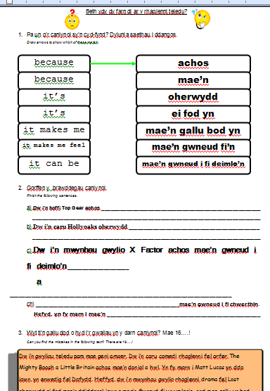 | - Pupils to follow instructions.  - Using dictionaries, work as a class to think of suitable adjectives to express a like or dislike for television programmes.  - Make a note of these in table form on the back of this worksheet, a column each for positive and negative adjectives.
Slide 6 | - Pupils to work in groups to verbally express their opinions on the television programmes.  - Encourage pupils to agree and disagree, giving reasons to support their opinion.  - Pupils then to write their opinions about the television programmes. | Differentiation:  Lower ability: Teacher may specify certain programmes, asking for one or two sentences on each one.  Middle ability: May write sentences on each programme, or a paragraph on a lesser number, encouraging use of linking words to make the paragraph progress appropriately.  Higher ability: May write about all the programmes, in a continued piece of writing showing evidence of planning and appropriate progression, by making use of a wide range of phrases and comparing the programmes.  All abilities should be encouraged to write about the programmes they like and dislike and give reasons to support opinion.
Slide 7 | - A quick extension activity where pupils translate the paragraphs.  - A click will reveal the correct translation. | Further extension task: Pupils to work in groups to improve the answers.
Word Document  Darllen a deall Ellie  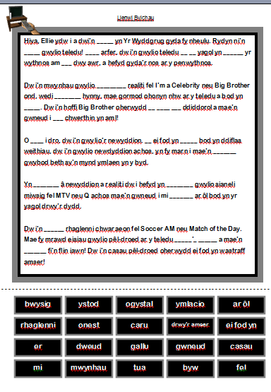 | - Pupils should fold the worksheet under at the dotted line and work, wither individually or in pairs, to fill in the blanks.  - When they have done all they can, the may unfold the words to verify and support their work. | Lower ability pupils may begin with the missing words rather than folding.
Power Point  Darllen a Deall Ellie  Slides 1-6 | - View Ellie’s text in its entirety.  - Clicking the microscopes will focus on the particular paragraph.  - Verify the pupils’ gap filler answers, asking individuals to read aloud. | A good opportunity to revise skills in reading aloud.
Slides 7-8 | 1. Reading comprehension. | A good opportunity to revise skills in reading comprehension and using the third person in answering.

